**PHARMACY MANAGEMENT SYSTEM**

|  |  |
| --- | --- |
| **Members** | **Contribution** |
| **Zeeshan Zulfiqar Dossani**  **(2017-SE-106)** | **Back End**  **Database** |
| **Shahab Younus**  **(2017-SE-122)** | **Front End (GUI)**  **SRS Report** |
| **Zeeshan Amir Khan**  **(2017-SE-108)** | **SRS Report** |

**Chapter 1**

**1.1 Introduction**

The Pharmacy Management System, in all its uniqueness, is a comprehensive solution for efficient, quick and elegant management of a medical enterprise which includes a wide array of functional activities ranging from medicine and store management to supply and transaction processing.

* 1. **Problem Statement**

To build a Management System that can efficiently handle all the functional activities of a pharmaceutical enterprise- Store Management, drug management, transactions, distribution and supply.

**1.3 Objectives of the project**

1. To handle the data of all stores affiliated to a particular enterprise and means to setup records of an allocated store.
2. To handle the distribution of medicines to each store whereby a virtual representation of a dealer/distributor/supplier is considered.
3. To manage and monitor all the transactions associated with every store, and to be able to retrieve the details of the desired transactions.
4. To keep a constant track on the medicines available in each store, their expiry status, and the quantity. Necessary measures are to be taken as and when the above said status hits an undesirable mark.
5. To obtain useful statistical information about the entire system, (e.g.: The list of medicines that are the best sellers), which may provide a great impetus for the organizations to expand and improve their business, ultimately benefitting the society.
6. To provide security in terms of authentication so that only the authorized personnel is allowed to carry out his activities in his sphere of control.
7. To ensure interoperability between the various functional units which may be accomplished by coordinated messages and requests, while at the same time maintaining the integrity of each unit.

**CHAPTER 2**

**SYSTEM DESIGN AND METHODOLOGY**

**2.1 System Architecture**

**Softwares used:**

|  |  |
| --- | --- |
| **Software Used** | **Version** |
| Sql Server Management Studio | 2012 |
| JAVA | jdk1.8.0_121 |
| Eclipse | 4.7.3a |
| Scene Builder | 8.4.1 |

The Pharmacy Management System comprises of three main units:

1. Administrator
2. Stores
3. Dealer

1. The Administrator is the owner of the pharmaceutical enterprise and is solely responsible for the management of the system. The functions of the administrator are to:
2. Set up new records for a new store establishment, or for the removal a current establishment, and convey the authentication information to the respective store manager (as shown in Fig.1.4).
3. Announce the arrival of new medicines to all the stores under the enterprise
4. Update the information of medicines regularly
5. Set up records for a new dealer which the enterprise ascribes to, and convey the authentication information to the respective dealer
6. Update the dealer information regularly
7. Monitor the activities of stores, and keep a track on the transactions associated with every store that forms a part of the organization
8. To assign the requests of medicines from the stores to the dealers based on his discretion (usually referring to the cost table hosted by each dealer).
9. To analyze the statistical information gathered from all stores. Provisions are provided to view the details of a particular store or a dealer. For example, the administrator has to type in the dealer_id, and the stores that he supplies to along with the quantity are retrieved.
10. Stores are independent establishments or openings, from where medicines are sold to the customers. The administrator can create any number of stores and assign each of these stores with login credentials. Each store is managed by a store manager, who keeps track of the medicines, the rack number, and the quantity of each medicine and the expiry status of the medicines. If falling short of a medicine (or if more stock is desired), the store has to initiate a request to the administrator.

The request comprises the medicine and the quantity necessary.

The administrator looks up all the dealers’ cost table (which shows the required medicine and the cost hosted by each dealer) and chose the dealer which he feels is viable to deal with. (The colored lines in Fig.1.4 represent distinct requests from each store).

After receiving the stock, the stores initiate transactions with the customer, and the details of the medicine bought, the quantity and the total amount is recorded and stored in the database. Appropriate triggers are used to alter the quantity of medicine in a store after a transaction between the store and a customer takes place or after a dealer supplies to a store.

1. The dealer represents the virtual link between the enterprise and the actual dealer. The dealer has two primary important functions. Intuitively,
2. The dealer is responsible for supplying the stores with the desired medicine and quantity. (The request for supply is directed to a dealer after the administrator chooses him for a particular medicine)
3. The dealer hosts his cost table which contains information about the medicines and the cost that he intends to charge (usually below the MRP of the medicine).

**2.2 ER Diagram:**

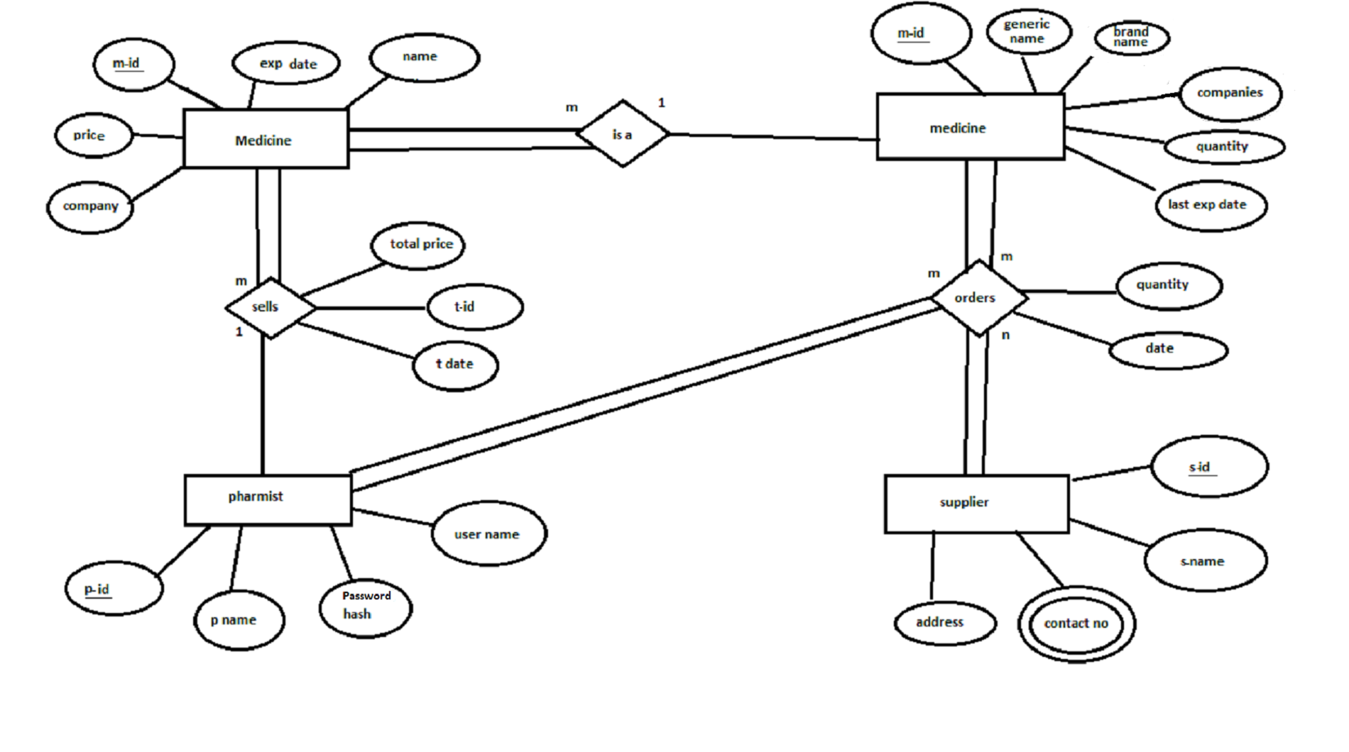

**2.3 Normalization**

Normalization not possible in our system because we don’t have multiple primary keys in any table.

**CHAPTER 3**

**SYSTEM IMPLEMENTATION**

**3.1 MODULE DESCRIPTION**

**1. Add Pharmacist**

It is the sign up page. For using this software every new pharmacist should add their name, id, user name so he or she will be able to access this software.

**2. User Login**

This is the login page basically. Here pharmacist will be able to login for using pharmacy management system and for performing desired work.

**3. Product**

It is the main page. Whenever pharmacist login into system, this page displayed multiple of option, here add medicine, search medicine and sign out option displayed. Main functionality of this page is to displayed quantity, expiry date, validation and manufacturing date.

**4. Search Medicine**

Here pharmacist have authority to search medicine by their brand name, company, medicine id, generic name or by expire date.

**5.**  **Medicine Information**

Here medicine information displayed which was search by the pharmacist on the search medicine page. Here all information displayed such as brand name, company, medicine id, generic name or by expire date.

**6. Add Product**

Here pharmacist may add product which was short in the pharmacy and recently add so system will be updated by pharmacist.

7. **Order Page**

This page is for order placing so here pharmacist add every information of supplier, person who purchases medicine.

**CHAPTER 4**

**RESULTS AND SCREENSHOTS**

**1. User Login**

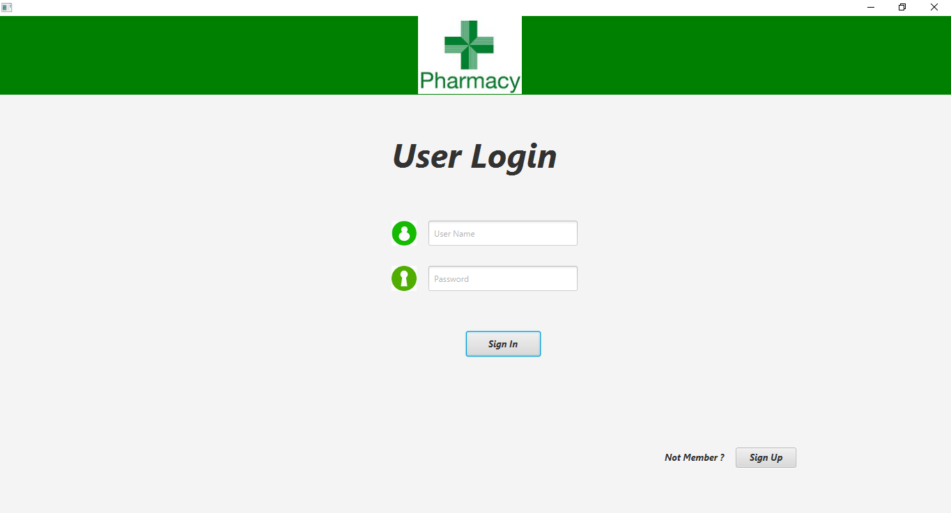

**2. Add Pharmacist**

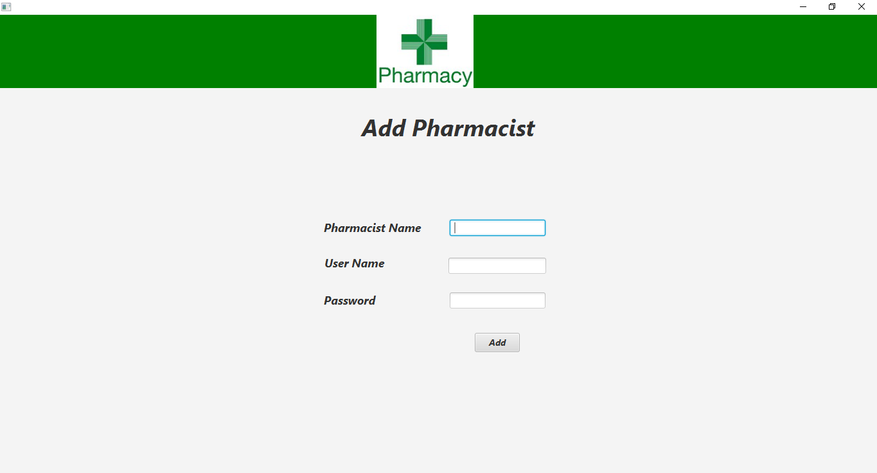

**3. Product**

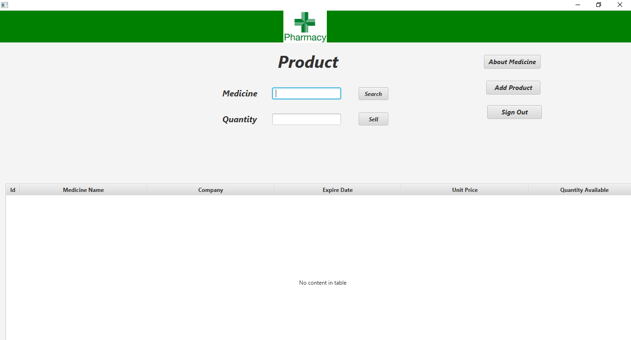

**4. Search Medicine**

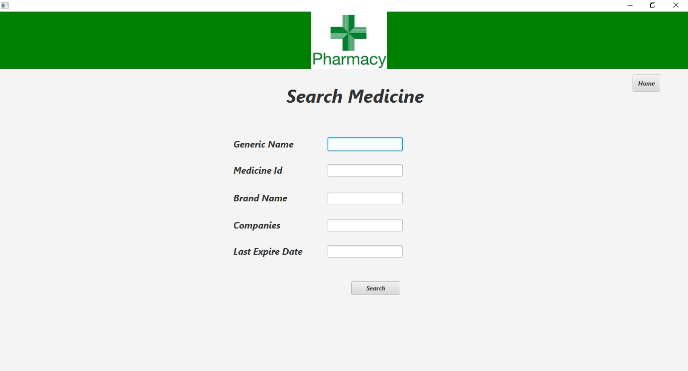

**5.**  **Medicine Information**

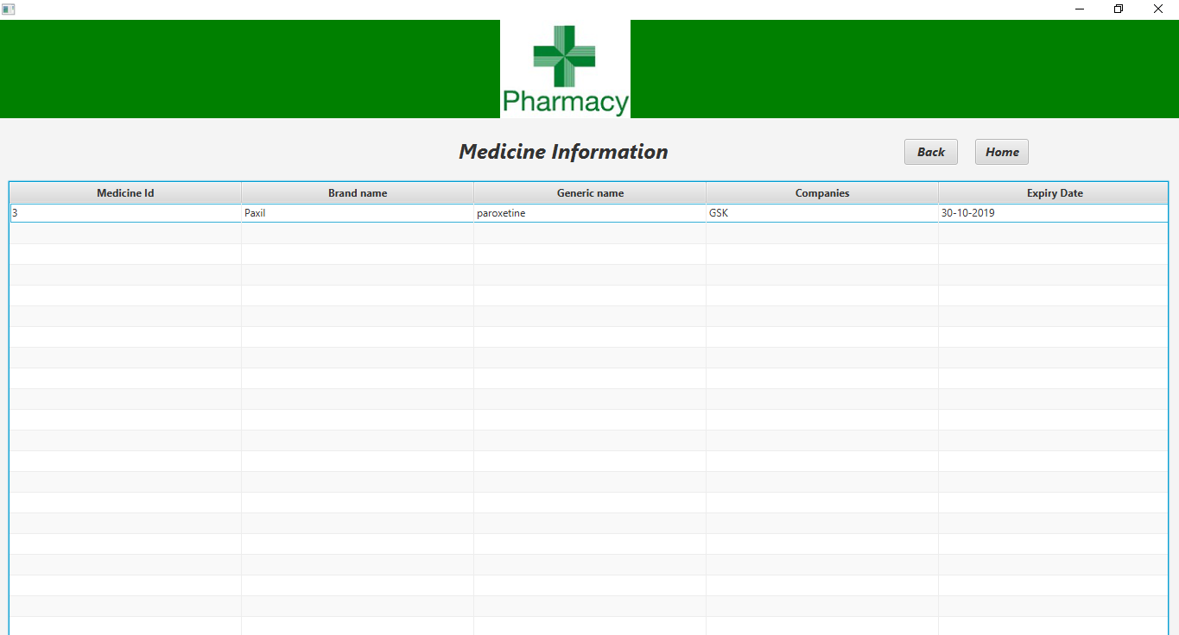

**6. Add Medicine**

